List of investment projects of Miorsky district proposed for implementation using investor funds
Сustomer | Project Name | Total investments, thousand US dollars | Infrastructure
AK-Miory Limited Liability Company, Vitebsk Region, Miory, ul. Vokzalnaya, 6-4, cab.2, tel. 375 29 577-77-77 | Establishment of an inter-district medical center in Miory | 90 000,0 | The presence of a land plot, adjacent to the republican road R14, near the line of power lines and the gas supply network, 3 km railway | 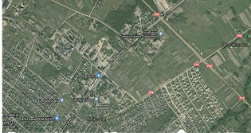
AK-Plaza Limited Liability Company, Vitebsk Region, Miory, 6 Vokzalnaya St., 3-3, tel. 375 29 577-77-77 | Construction of the Multifunctional Complex in Miory | 150,0 | The presence of a land plot, adjacent to the republican road R14, near the line of power lines and the gas supply network, 4 km railway | 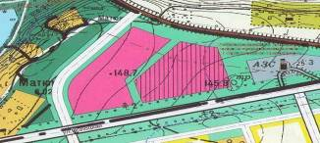
Production unitary enterprise "Miorsky meat processing plant," Vitebsk region, Miory, st. Severnaya, 8B,  tel. 375 2152 4-19-31  e-mail: miorym@yandex.by | Organization of innovative production of meat products based on export-oriented introduction of new technologies of slaughter, processing and storage | 3663,5 | Production areas of the enterprise, availability of transport and engineering infrastructure | 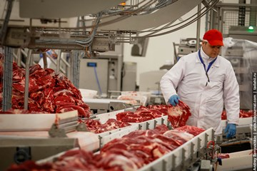
Department of Education of the Miorsky District Executive Committee, Vitebsk Region. Miory, st. Communist, 8,  ph. 375 2152 5-15-80,  fax 375 2152 5-03-39 | Design and construction of the facility "Kindergarten for 200 places in Miory" | 4500,0 | Land availability, power supply, gas supply, water supply and drainage | 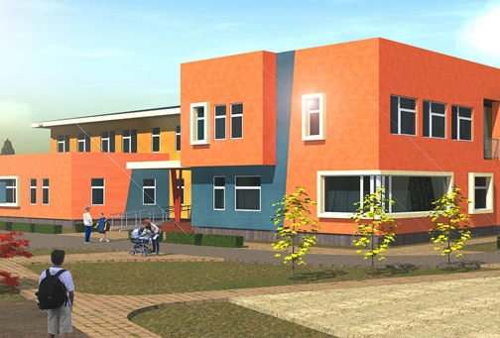
Miorsky District Executive Committee, 211287 Vitebsk Region, Miory st. Dzerzhinsky, 17 Tel/fax: 3752152 5-19-02, e-mail: economikamiory@vitebsk.by | Construction Waste Management | 1000,0 | Production site of Miory, st. Vokzalnaya, availability of transport and engineering infrastructure | 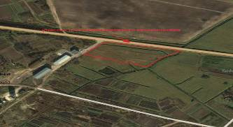
Miorsky District Executive Committee, 211287 Vitebsk Region, Miory st. Dzerzhinsky, 17 Tel/fax: 3752152 5-19-02 e-mail:  economikamiory@vitebsk.by | Organization of production for the collection and processing of berries and mushrooms | 750,0 | Production site of the existing enterprise, availability of transport and engineering infrastructure | 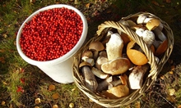
MMPZ Group Limited Liability Company  Tel/Fax: 3752152 5-13-37 e-mail: support@mmpz.by | Construction of roads to the residential building of the plant and to the medical center, Miory, ul. Partizanskaya, st. Communist | 5000,0 | Availability of 8 hectares of land | 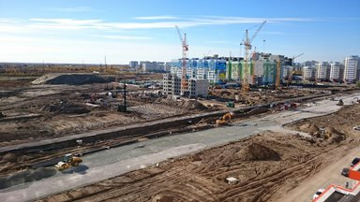
Miorsky District Executive Committee, 211287 Vitebsk Region, Miory st. Dzerzhinsky, 17 Tel/fax: 3752152 5-19-02 e-mail:  economikamiory@vitebsk.by | Construction of a hotel in Miory on Oktyabrskaya St. | 1560,0 | The presence of a land plot on the street. October city of Miory, the presence of transport and engineering infrastructure | 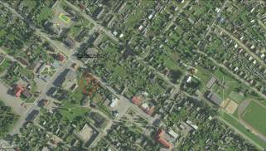
Miorsky District Executive Committee, 211287 Vitebsk Region, Miory st. Dzerzhinsky, 17 Tel/fax: 3752152 5-19-02 e-mail:  economikamiory@vitebsk.by | Construction of bicycle paths and development of bicycle route of cyclists movement using rental point, recreation areas and various services | 250,0 | Availability of land, transport infrastructure | 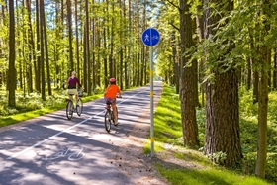
Miorsky District Executive Committee, 211287 Vitebsk Region, Miory st. Dzerzhinsky, 17 Tel/fax: 3752152 5-19-02 e-mail:  economikamiory@vitebsk.by | Arrangement of parking for camping in ag. Uzmeni | 50,0 | Availability of transport infrastructure, bridge | 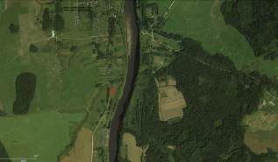
Miorsky District Executive Committee, 211287 Vitebsk Region, Miory st. Dzerzhinsky, 17 Tel/fax: 3752152 5-19-02 e-mail:  economikamiory@vitebsk.by | Arrangement of the forest approach to the ecological trail along the Yelnya swamp 800 m for persons with disabilities | 170,0 | Transport infrastructure near road R14, access roads | 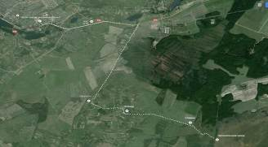
Unitary enterprise of housing and communal services, 211287 Vitebsk region, Miory, st. Station, 5/1, Tel/fax: 375 2152 5-24-56, 5-24-76, e-mail: miorigkx@mail.ru | Construction of a complex for processing municipal solid waste of the Miorsky district | 10000,0 | Availability of land, transport and engineering infrastructure | 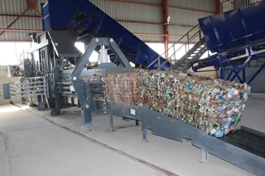
AK-Miory Limited Liability Company, Vitebsk Region, Miory, ul. Vokzalnaya, 6-4, cab.2, tel. 375 29 577-77-77 | Construction of a rehabilitation and rehabilitation center near the village of Zacherevye, Perebrodsky Village Council | 100000,0 | Availability of land, transport infrastructure | 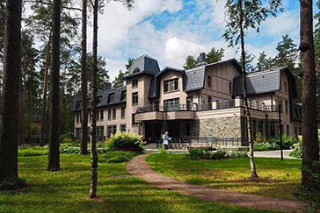
Miorsky District Executive Committee, 211287 Vitebsk Region, Miory st. Dzerzhinsky, 17 Tel/fax: 3752152 5-19-02 e-mail:  economikamiory@vitebsk.by | Construction of a clinic in Miory | 6300,0 | Availability of land, transport infrastructure | 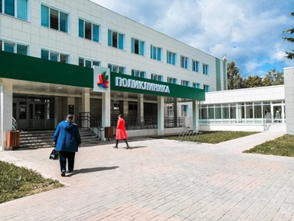
Miorsky District Executive Committee, 211287 Vitebsk Region, Miory st. Dzerzhinsky, 17 Tel/fax: 3752152 5-19-02 e-mail:  economikamiory@vitebsk.by | Construction of electrode plant | 6230,0 | Availability of land, raw materials base, transport infrastructure | 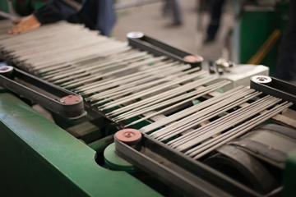
Miorsky District Executive Committee, 211287 Vitebsk Region, Miory st. Dzerzhinsky, 17 Tel/fax: 3752152 5-19-02 e-mail:  economikamiory@vitebsk.by | Organization of production of professional oil and other building materials | 520,0 | Availability of land, raw materials, transport infrastructure | 
Miorsky District Executive Committee, 211287 Vitebsk Region, Miory st. Dzerzhinsky, 17 Tel/fax: 3752152 5-19-02 e-mail:  economikamiory@vitebsk.by | Establishment of a logistics centre in Miora | 1000,0 | Availability of land, transport infrastructure | 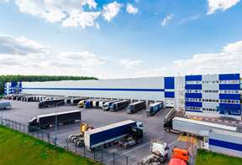
Branch of the Miorski Road Repair and Construction Department No. 203 of the municipal design and repair and construction unitary enterprise Vitebskobldorstroy, 211287 Vitebsk region, Miory, ul. Communist, 55 Tel/fax: 3752152 4-22-36 e-mail: drsup203@vitebsk.by | Construction of a bridge over the Outa River | 350,0 | Availability of transport infrastructure | 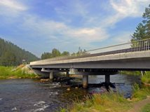
Wendorozhsky Lakes Limited Liability Company,  Ph. +375 2152 5-19-02, e-mail:  economikamiory@vitebsk.by | Creation of the agricultural estate "House of the Hunter and Fisherman" on the basis of a complex of unused property in the village of Perebrodye | 300,0 | Availability of real estate, natural resources (lakes in the region of 300-500 m, forest), land, transport infrastructure | 