No. P/N | name of the object | location address | balance sheet holder | brief description of the object | photo
1 | 2 | 3 | 4 | 5 | 6
1. | Reinforced concrete and RBU plant, inv. N 211/С-7970 | Miory, 47/4 Kommunisticheskaya str. | Unitary enterprise of housing and communal services of the Miorsky district | The brick building was built in 1970, reconstructed in 2022 with reinforced concrete slabs, with a total area of 1196.6 sq m, power supply, water supply, sewerage, access roads, 0.5 km from the republican road R14, 3 km from the railway station | 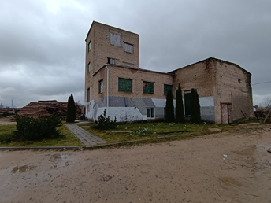
2. | Seed warehouse, inv. No.254/С-112541 | Miory, Pionerskaya str., 44A | Unitary enterprise of housing and communal services of the Miorsky district | The brick frame building was built in 1955 with a total area of 671.0 sq m, there are power supply networks, water supply, sewerage, access roads, 1.0 km from the republican road R14, 1.0 km from the railway station | 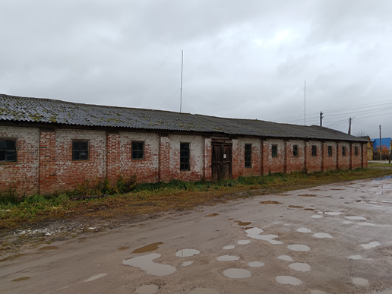
3. | Capital buildings complex (4 buildings of the former Tsvetinskaya school) school building inv.No. 254/C-12026, vegetable storage building inv.No. 254/C-12025,school warehouse No. 254/C-12027, boarding school building No. 254/C-11317 | Miorsky district, Zautyevsky village, ag. Tsvetino, Titova p., 24,24/1,26,26/1 | Department of Education of the Miora District Executive Committee | The brick school building was built in 1965 with a total area of 1007 sq. m, the brick vegetable storage building was built in 1985 with a total area of 24.3 sq. m., the brick school warehouse was built in 1958 with a total area of 68.2 sq. m., the boarding school building is brick, two-storey built in 1983 with a total area of 480.4 sq. m. They are located on a plot of land with a total area of 4,7105 hectares.  Power supply network, water supply, sewerage. | 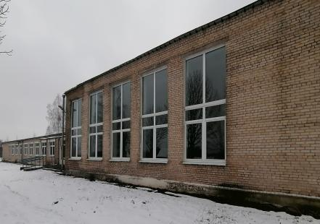
4. | School building, inv. No. 254/С-12116 | Miorsky district, Zautyevsky village, Zautye village, Shkolnaya str. , 4 | Department of Education of the Miora District Executive Committee | The building is brick, two-storey, built in 1994, with a total area of 2114.2 sq.m. it is located on a plot of land with an area of 1.3132 hectares. Power supply network, water supply, sewerage. | 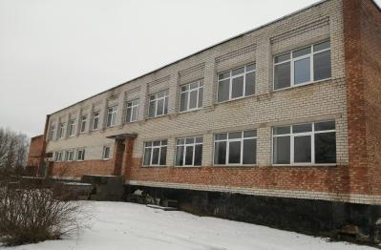
5. | Complex of capital buildings (3 buildings of the former school), 254/S-12182 (school building) | Miorsky district, Turkovsky village, d. Driguchi, Tsentralnaya str., 1A, 1B | Department of Education of the Miora District Executive Committee | The school building is two-storey, brick built in 1995, with a total area of 1582.1 sq. m., the building of livestock classes is one-storey, brick, with a total area of 255.5 sq. m., the boiler house building built in 1995 is one-storey, brick, with a total area of 105.9 sq. m  . Power supply network, water supply, sewerage. | 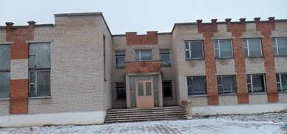
6. | Land plot (for the construction and maintenance of a catering facility),  223382116501000007 | Miorsky district, Miorsky village,  Masevtsy village | Miorsky district | The land area is 0.2278 hectares, located near the republican road P14 | 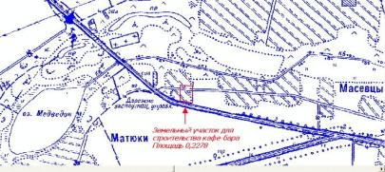  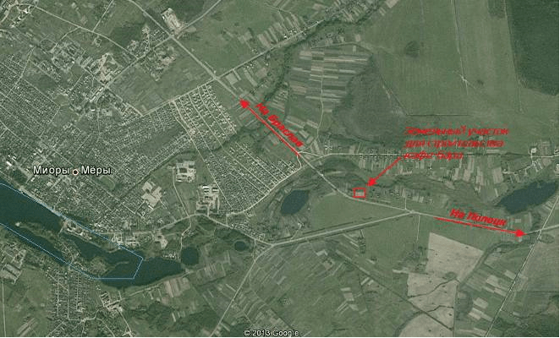
7. | Land plot (for the construction and maintenance of a catering facility),  223383037001000007 | Miorsky district, Novopogostsky village, Chepuki village | Miorsky district | The land area is 0.2808 hectares, located near the republican road R18 | 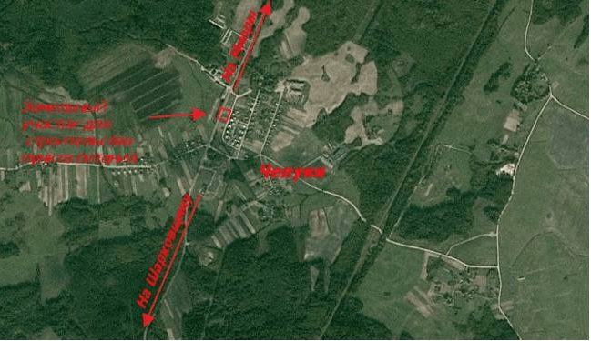
8. | Land plot (for the construction and maintenance of a catering facility),  223381716101000085 | Miorsky district, Zautyevsky village, Ostevichi village | Miorsky district | The land area is 0.3364 hectares, located near the republican road P14 | 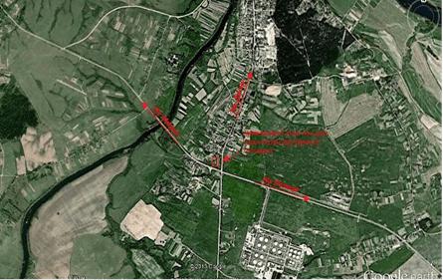  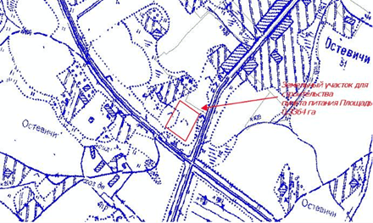
9. | Land plot | Miory, Vokzalnaya street | Miorsky district | The area of the land plot is 2.0 hectares near the republican road P14, 500 m from the railway line | 